ASSIGNMENT 16

Name : Akanksha Joshi

Roll No : B038

Batch : 3

Div : BTech CS B

--------------------------------------------------------------------------------------------------------------------------

Q.Accept a string as an input from the user. Check if the accepted string is a palindrome or not.If the string is a palindrome , print “String is palindrome ” , otherwise print “String is not palindrome”. Also print the actual and reversed string.

Source Code

my_string = input("Enter a string : ")

my_string = my_string.casefold()

rev = reversed(my_string)

if list(my_string) == list(rev):

print("It is a Palindrome")

else :

print("Not a Palindrome")

Output

1. When string is a palindrome

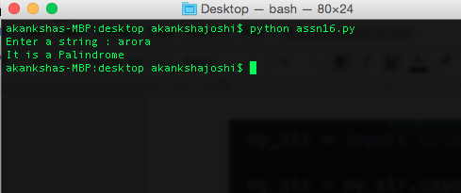

B. When string is Not a palindrome

